

PROJECT REPORT
ON
MOOD VS PRODUCTIVITY AI ANALYZER
Degree of Bachelor of Technology
In
Computer Science and Engineering (AIML)
By

NAME :- TANISHKA JOSHI
REGISTRATION NUMBER :- 25BAI10767
INTRODUCTION

This project, “Mood Vs Productivity Analyzer using AI”, is designed to understand how a student’s daily mood, study hours, and sleep affect their productivity. As students, we often notice that our performance changes depending on how we feel, but we don’t usually track or analyze it properly. This project aims to solve that problem in a simple and practical way.
In this system, the user enters basic daily details such as mood (happy, neutral, or sad), number of study hours, and sleep duration. Based on this data, the program calculates a productivity score and gives useful suggestions to improve performance. It also uses graphs to visually show the relationship between mood, study, sleep, and productivity, making it easier to understand patterns.
Additionally, a basic machine learning technique (Linear Regression) is used to predict productivity based on past data. This helps in making the project more intelligent and closer to real-world AI applications.
** “This project can help students improve their daily routine by understanding their productivity patterns.”**

PROBLEM STATEMENT

Students often experience changes in their productivity due to factors like mood, study habits, and sleep, but they usually do not track or understand how these factors actually affect their performance. Many students feel unproductive or distracted without knowing the exact reason behind it.
There is no simple and easy-to-use system that helps students connect their daily emotions and habits with their productivity. Because of this, students are unable to identify patterns in their behavior or make improvements in their study routine.
This project aims to solve this problem by creating a basic system that takes inputs like mood, study hours, and sleep, and analyzes their impact on productivity. It also provides helpful suggestions and visual graphs so that students can better understand their habits and improve their performance over time.

FUNCTIONAL REQUIREMENT

- The system should allow the users to enter the daily details like mood, study hours, and sleep hours in a simple way.

- The system should convert mood into a usable format (like values) for further analysis.

- The system should calculate a productivity score based on the given inputs.

- The system should provide simple and helpful suggestions to improve productivity based on user data.

- The system should allow the user to add multiple entries to track performance over time.

- The system should display graphs and charts to help users easily understand the relationship between mood, study, sleep, and productivity.

- The system should use a basic machine learning technique to predict productivity from past data.

- The system should be easy to use and user-friendly, even for beginners.

- The system should show average productivity based on all entered data.
NON FUNCTIONAL REQUIREMENT

- The system should be simple and easy to use, so that any student can use it without confusion.

- The system should have fast performance, meaning it should quickly calculate productivity and show results without delay.

- The system should be reliable, giving correct calculations and consistent output every time.

- The system should be lightweight, so it can run easily on a normal computer without needing high specifications.

- The system should have a clear and understandable interface/output, so users can easily read results and graphs.

- The system should be maintainable, meaning the code should be easy to understand and update in the future.

- The system should be scalable, so more features (like 8. saving data or adding login) can be added later.

- The system should ensure basic data safety, meaning user data is not misused and stays within the program.
ALGORITHM

- Start the program
- Create empty lists to store:
2.1 Mood values
2.2 Study hours
2.3 Sleep hours
2.4 Productivity scores
3. Ask the user to enter their mood, study hours, and sleep hours
4. Convert the user’s mood (happy/neutral/sad) into a numerical value
5. Calculate the productivity score using a simple formula based on mood, study, and sleep
6. Store all the entered data and calculated productivity in the lists
7. Display the productivity score to the user
8. Provide basic suggestions based on:
8.1 Mood
8.2 Study hours
8.3 Sleep hours
9. Ask the user if they want to enter more data
9.1 If yes → repeat steps 3 to 8
9.2 If no → continue further
10. Generate graphs to show relationships:
10.1 Mood Vs Productivity
10.2 Study Hours Vs Productivity
10.3 Sleep Vs Productivity
11. If enough data is available:
11.1 Apply Linear Regression (ML)
11.2Predict productivity based on input data
12. Calculate and display the average productivity
13. End the program
FLOWCHART

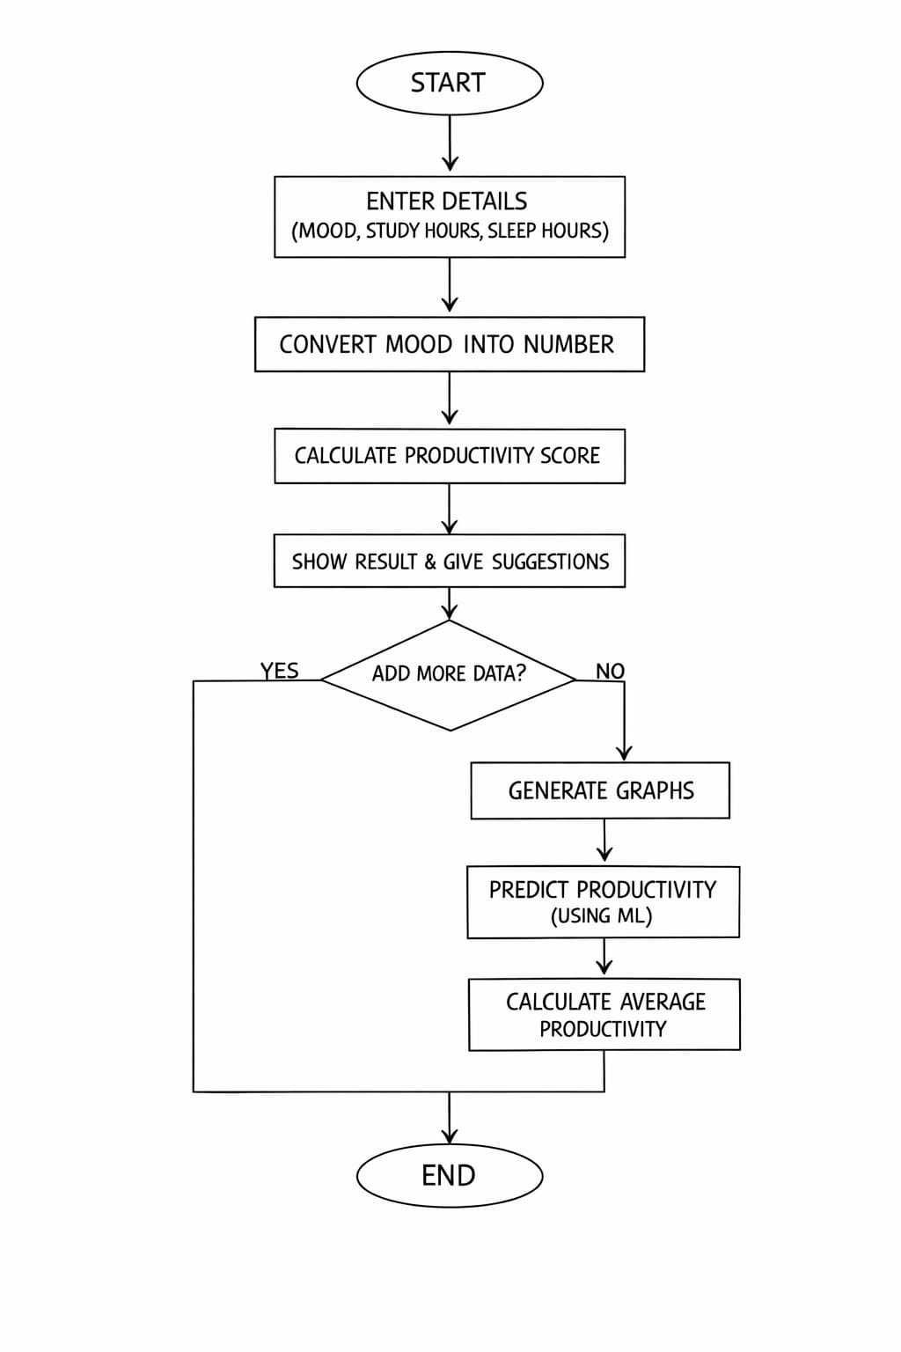

UPPER CASE DIAGRAM

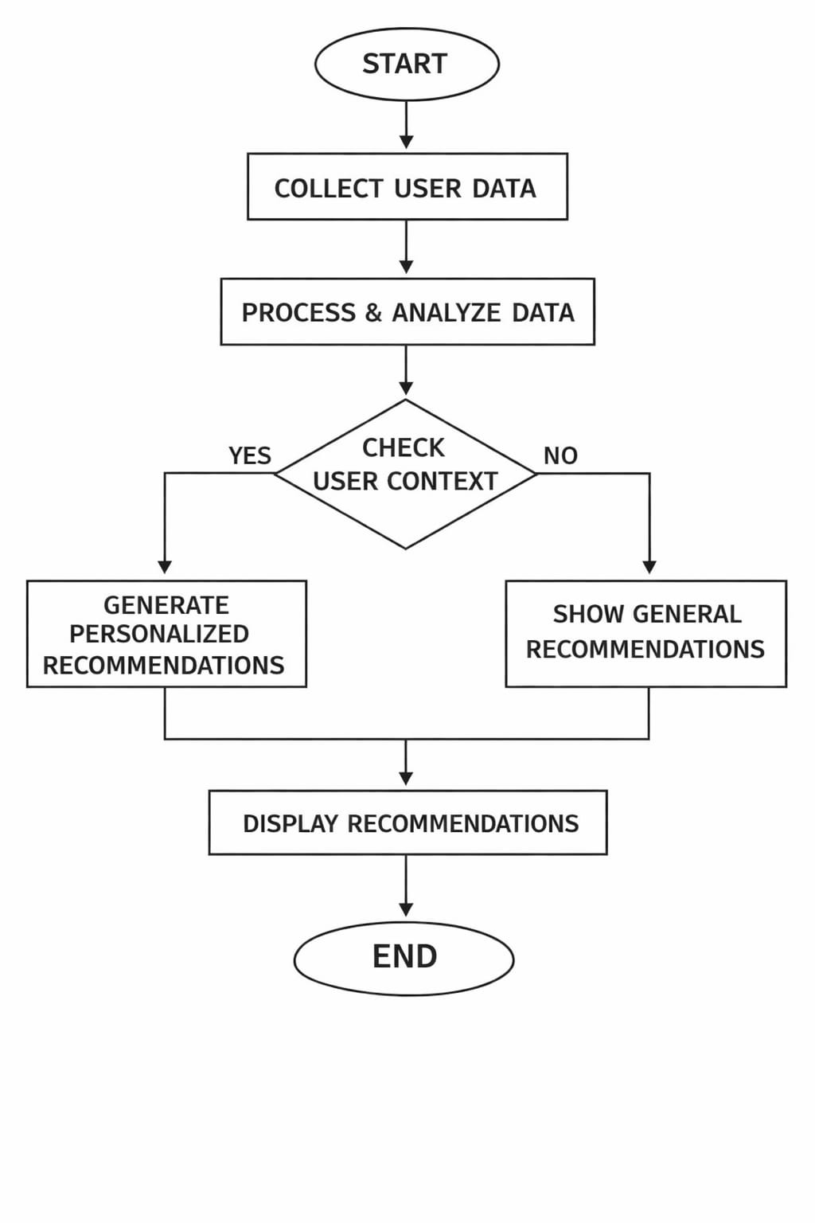WORK FLOW DIAGRAM
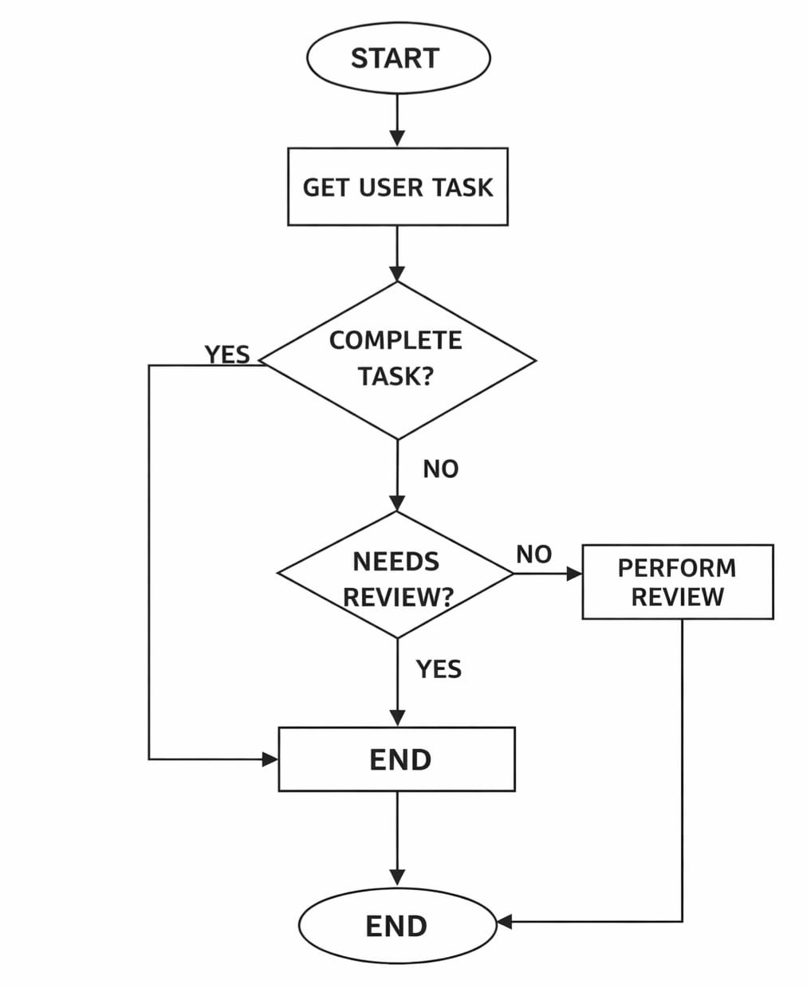
SEQUENCE DIAGRAM
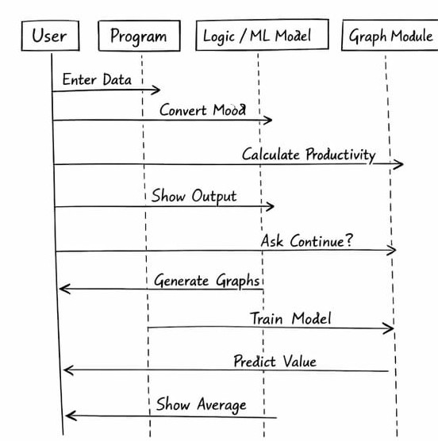
SYSTEM ARCHITECTURE
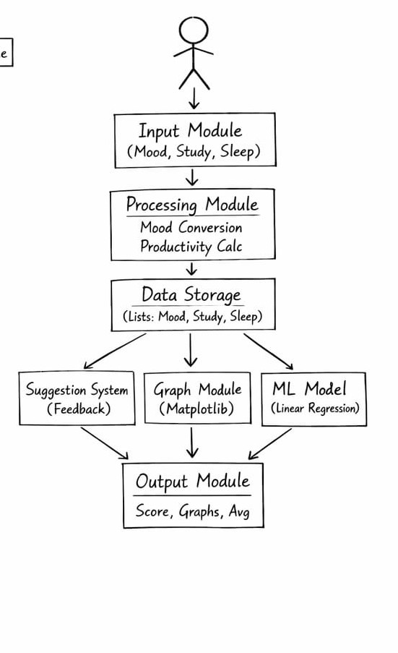
OUTPUT SCREENSHOT
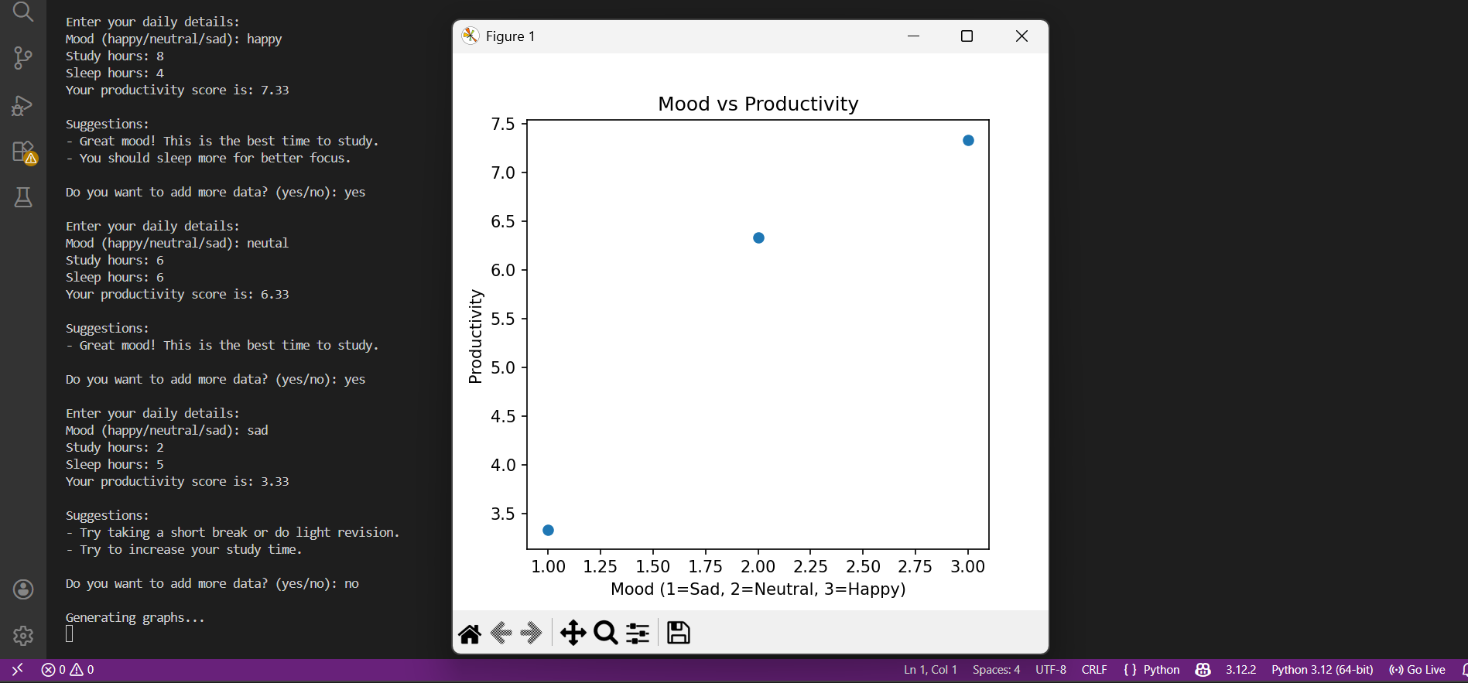
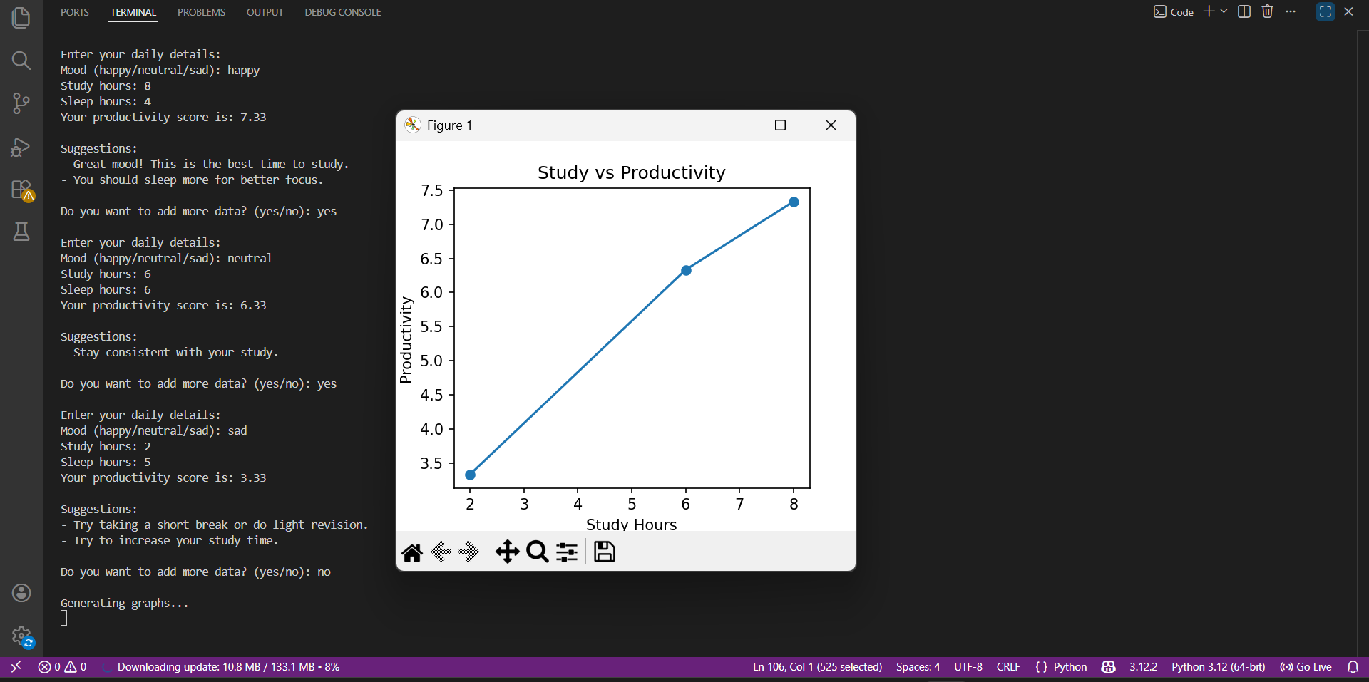

DESIGN DECISIONS & RATIONALE

While designing this project, the main focus was to keep the system simple, easy to understand, and useful for students.
First, only basic inputs like mood, study hours, and sleep hours were taken. This decision was made because these are common factors that affect every student’s daily productivity and are easy to enter without any confusion.
The mood is converted into numerical values so that the system can process it easily. This helps in performing calculations and also makes it possible to apply machine learning later.
A simple formula is used to calculate productivity instead of using complex methods. This keeps the project easy to understand and suitable for a beginner level.
The system also provides suggestions based on the user’s input. This was added to make the project more interactive and helpful, so users can improve their habits.
Graphs are included to visually represent the data. This decision helps users easily understand the relationship between mood, study, sleep, and productivity instead of just reading numbers.
A basic machine learning algorithm (Linear Regression) is used to predict productivity. This was chosen because it is simple and perfect for beginners who are just starting with AI and ML.
The project is developed using Python because it is easy to learn and widely used in AI-based applications.
Finally, a simple console-based interface is used instead of a complex design. This helps in focusing more on logic and functionality rather than appearance.
IMPLEMENTATION DETAILS

In this project, I have used Python to build the system because it is easy to understand and suitable for beginners.
First, the program takes input from the user, such as mood, study hours, and sleep hours. Since mood is given in words like happy, neutral, or sad, I converted it into numbers so that it can be used in calculations easily.
After taking the input, I used a simple formula to calculate the productivity score. This gives a basic idea of how productive the user was based on their daily habits.
To store the data, I used lists so that multiple entries can be saved. This helps in analyzing the data later and also improves the accuracy of results.
I also added some simple conditions in the program to give suggestions. For example, if the user studies less or sleeps less, the program gives advice to improve their routine.
For visualization, I used graphs to show the relationship between mood, study hours, sleep, and productivity. This makes it easier to understand the data instead of just looking at numbers.
I also used a basic machine learning method called Linear Regression to predict productivity based on the data entered by the user. This adds a simple AI feature to the project.
Overall, I tried to keep the implementation simple and clear so that it is easy to understand and also useful in real life.

FORMULA USED
Productivity = (Mood × 2 + Study × 1.5 + Sleep) / 3)
TESTING TABLE

TEST CASE | INPUTGIVEN | EXPECTED OUTPUT | ACTUALOUTPUT | RESULT
1 | Mood: happy, Study: 5, Sleep: 6 | High productivity score | High productivity shown | Pass
2 | Mood: sad, Study: 2, Sleep: 4 | Low productivity score | Low productivity shown | Pass
3 | Mood: neutral, Study: 3, Sleep: 5 | Medium productivity score | Medium productivity shown | Pass
4 | Study hours less than 3 | Suggestion to increase study time | Suggestion displayed | Pass
5 | Sleep hours less than 5 | Suggestion to improve sleep | Suggestion displayed | Pass
6 | Less than 3 entries | ML prediction not shown | Message displayed correctly | Pass
7 | More than 3 entries | ML prediction should work | Prediction displayed | Pass

CHALLENGES FACED
While working on this project, I faced a few challenges in the beginning. Since this was my first time combining different concepts like user input, calculations, graphs, and machine learning, it was a bit confusing at first to connect everything properly.
One of the main challenges was handling user input and converting mood (like happy, neutral, sad) into numerical values so that it could be used in calculations. I also found it difficult initially to understand how to create graphs and represent data visually.
Another challenge was using machine learning. As a beginner, understanding how Linear Regression works and how to apply it in the project required some effort and practice.
Apart from this, I also faced small issues like errors in code and making sure the program runs smoothly.
However, by learning step by step and practicing regularly, I was able to overcome these challenges and successfully complete the project.
LEARNING & KEYS TAKE AWAYS
Through this project, I learned how to apply basic programming concepts to solve a real-life problem. It helped me understand how user input can be taken, processed, and used to generate meaningful results.
I also learned how to work with data by storing multiple entries and analyzing them. Creating graphs helped me understand the importance of data visualization and how it makes information easier to understand.
One of the key learnings was getting introduced to basic machine learning. I understood how Linear Regression can be used to find relationships between different factors and make predictions.
This project also improved my problem-solving skills, as I had to fix errors and connect different parts of the program step by step.
Overall, the project gave me a better understanding of how AI concepts can be applied in simple and practical ways, and it increased my confidence in building small projects on my own.

FUTURE ENHANCEMENTS

In the future, this project can be improved in many ways to make it more useful and user-friendly. One of the main improvements can be adding a proper interface with buttons and design, so that users can use it easily instead of typing everything in the terminal.
Another improvement can be saving the user’s data, so that it can be used later for long-term tracking and better analysis. This will help in understanding productivity patterns over a longer period of time.
The project can also be enhanced by using more advanced machine learning techniques to make predictions more accurate. Additional factors like stress level, physical activity, or daily routine can also be included to make the system more detailed and realistic.
Some extra features like reminders or notifications can be added to help users stay consistent with their habits.Overall, with these improvements, the project can become more interactive, accurate, and useful in real-life situations.

REFERENCES

1. Python Software Foundation, Python Documentation. Available at: https://docs.python.org/

2. Matplotlib Developers, Matplotlib Documentation. Available at: https://matplotlib.org/stable/index.html

3. Scikit-learn Developers, Scikit-learn: Machine Learning in Python. Available at: https://scikit-learn.org/stable/

4. NumPy Developers, NumPy Documentation. Available at: https://numpy.org/doc/

5. Various online tutorials and educational videos on Python programming, data visualization, and basic machine learning concepts.

CONCLUSION

This project helped me understand that productivity is not only about how many hours we study, but also depends a lot on our mood and sleep. Through this project, I was able to see how small daily factors can actually make a big difference in performance.

While working on it, I learned how to take user input, process data, and present it in a meaningful way using graphs. I also got a basic idea of how machine learning works by using Linear Regression to make predictions.

Overall, this project was a great learning experience for me. It not only improved my technical skills but also helped me understand my own daily habits better. This project shows how simple ideas can be used to solve real-life problems in an easy and practical way.



